**Implementation document**

**Coding Standards**

We followed the corresponding python documentation [1] to allow for a more consistent and easy to follow project. The document gave us guidelines to follow for recommended programing practices and styles, as we were relatively new to the language.

E.g. no undescriptive variable names, no variable names beginning with a capital, etc.

For the Java code we used common standards we had learnt through University like common naming conventions and programming paradigms along with references to a java coding standards document [2] to write efficient code for the machine client files.

**Refactoring of code**

After the initial design stage, and once actual development had begun, we refactored code after every milestone delivery i.e. after the implementation, testing and deployment phases. This refactoring consisted of redefining and designing the layout of code, and revising variable names to be consistent with the web2py framework or the standards above.

The differences in the code itself can be seen from the first version to the last, where variable names have changed and packages have been refactored. The java client program itself is actually refactored and packed into a jar with a different dev_id embedded into it for every new device to be added.

**Repository**

We chose to use a GitHub repository to keep track of changes to any files we would be working on as a group. Everyone in the team was given training on how it worked, and eventually uploaded any files involved with the project onto it. Each team member was made a collaborator so they could push from remote locations, straight to the master branch. This allowed us to re-visit any old files we thought could perhaps be useful in a user friendly, distributed way.

<https://github.com/i7657043/artefacts>

**Class Diagram**

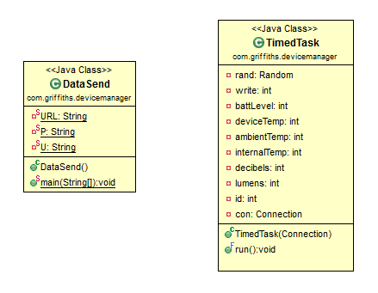

**References**

[1] python.org. (2017). *PEP 8 -- Style Guide for Python Code.* Available: https://www.python.org/dev/peps/pep-0008/. Last accessed 08/05/2017

[2] google.com. (n/a). *Google Java Style Guide.* Available: https://google.github.io/styleguide/javaguide.html. Last accessed 09/05/2017.